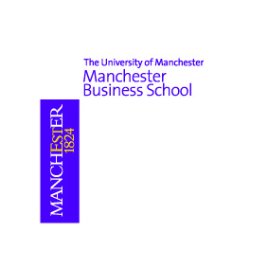

Taster Workshop: Strategic management
- at a glance
The key to becoming a successful strategic leader!

We are delighted to invite you to join the taster workshop on 18 September. The details is as follows:
Guest Speaker: Dr. Bob Vass
Date: September 18, 2009 (Friday)
Time: 7:00 – 8:30pm
Venue: Manchester Business School Worldwide East Asia Centre, 6/Floor, Wilson House, 19-27 Wyndham Street, Central, Hong Kong
Fee: Free of charge. By invitation only
*First come first served basis*

In this workshop you will learn:
- to analyse a business, and its portfolio of businesses
- to understand its market and competitive environment
- to formulate, evaluate and implement methods to develop and grow your business

About the presenter:
Dr Bob Vass is a popular workshop director of the Strategic Management and Management Accounting Module of Part-time MBA programmes in Manchester Business School over 17 years. He has profound experience in teaching business executives internationally. Bob is also a consultant with over thirty years experience of working with major UK companies, small start-up businesses and, over the past decade, he has consulted extensively in the dynamic transformation of business in western Europe. This experience will be available to you in discussion during and after the seminar.

If you would like to attend the taster workshop, please forward your CV to us as soon as possible, and if you require any further information, please do not hesitate to contact us at 25264680 or mba@mbs.edu.hk.

