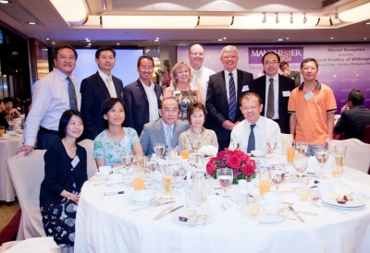
Alumni Reception and Buffet Dinner in Hong Kong

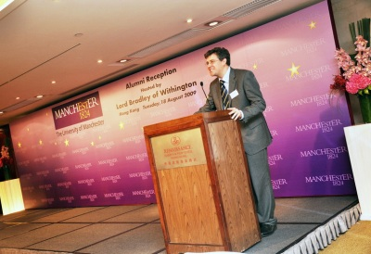
A most successful University event took place on 18 August in Hong Kong. The alumni reception and buffet dinner were hosted by Lord Bradley of Withington (Special Advisor to the President and Vice-Chancellor of the University Alan Gilbert) and demonstrated the great strategic importance of the University’s links with Hong Kong.
The reception and dinner were held at the stylish Renaissance Harbour View Hotel and were attended by over 225 alumni and friends.

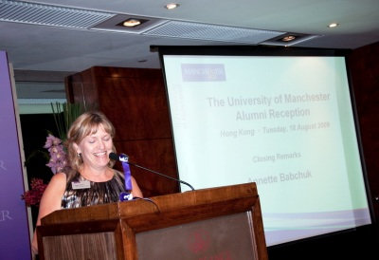
The evening rendezvous provided guests with the opportunity to meet and network with fellow alumni and with representatives from The University of Manchester including Chris Cox (Director of Development and Alumni Relations), Annette Babchuk (Head of Alumni Relations) and Joanne Speakman (Senior International Officer). The event was also attended by members of the Alumni Association Hong Kong committee including the Chair, William Lam (BSc Hons Electrical Engineering 1981).

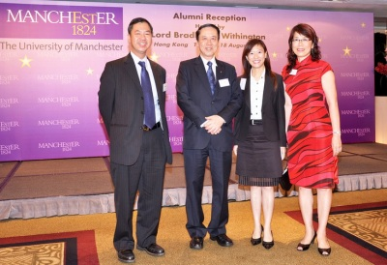
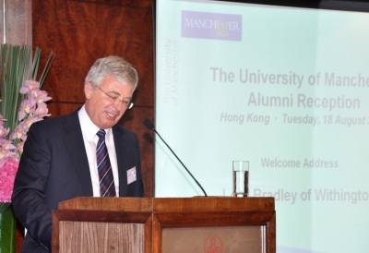
Guests were treated to a video presentation showing the latest developments taking place at the University and then a short address from Lord Bradley. Lord Bradley spoke of the long standing relationship between The University of Manchester and Chinese students, which began in 1905 with the admission of the first Chinese student, Chow Tien, from Beijing. Chinese was first taught at Owens College in 1901, when E H Parker was appointed to a part-time chair in Chinese – a post funded by an endowment from Henry Harrison of Blackburn who wished to encourage the teaching of Chinese.

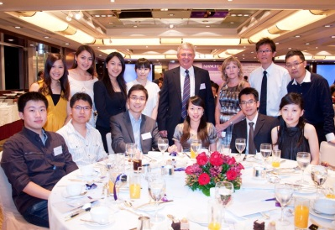
Lord Bradley explained “The University has always sought to play its part in promoting understanding of Chinese language and culture.” The University’s Centre for Chinese Studies was created in 2004, with the aim of developing a world leading research institution focusing on modern and contemporary China.

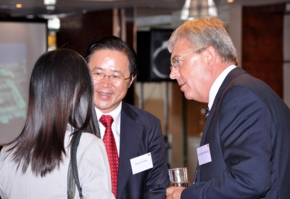
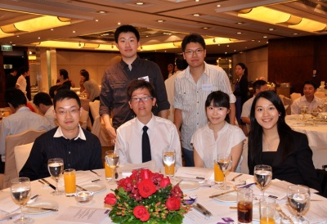
Lord Bradley outlined the current and future links between the University and alumni in Hong Kong: “Our links with Hong Kong and China have always been about bringing the best minds together,” he said. Lord Bradley also highlighted some of the investment in capital infrastructure at the University, which, he pointed out, in future would be “catalytic in creating a magnet in the North for some of the best brains worldwide,” and the University’s recent placement as the top five research universities in the UK, in the 2008 national Research Assessment Exercise (RAE).

In his closing remarks, Lord Bradley expressed his delight at the attendees' continued engagement with the University and encouraged the graduates to re-visit the University - now home to over 1,300 students from Hong Kong and China.

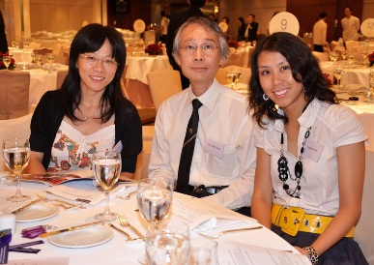
It is hoped that the event will be one of many to take place in Hong Kong in the future.

